**Window object**

Window is the object of the browser and window object represents the browser window or frame that displays the contents of the webpage .It is the top most object and outermost element of the object hierarchy. Window object has properties like browser history, location and the device screen etc. In very first step window object is loaded into the browser. In case of multi tab browser a window object represents a single tab, but some of its properties like innerHeight, innerWidth will affect the whole browser window. If you want to access a property of the window we can use window.property syntax .

**Document object**

Document is the object of window object and its represents the HTML file or webpage loaded into the browser .Each HTML document that gets loaded into a window becomes a document object. By changing the content of the document we can change the webpage content. The document contains the contents of the page. The document actually gets loaded inside the window object and has properties like title, URL, cookie, etc. If we want to access the properties of the document we can use window.document.propety syntax.

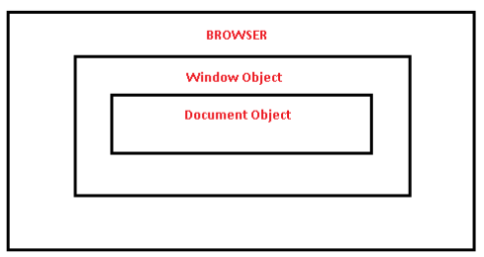

Difference between Window and Document object

|  |  |
| --- | --- |
| **Window Object** | **Document Object** |
| It represents a browser window or frame that displays the contents of the webpage. | It represents any HTML document or web page that is loaded in the browser. |
| It is the very first object that is loaded in the browser. | It is loaded inside the window. |
| The window is part of BOM, not DOM. | The document is part of BOM (browser object model) and DOM(Document object model). |
| It is the object of the browser. | It is the object of window property. |
| It is loaded before the document because window container document. | It is loaded after the loading window because the window contains a document. |
| We can access document object properties inside the window. | We can not access windows objects properties inside the document. |